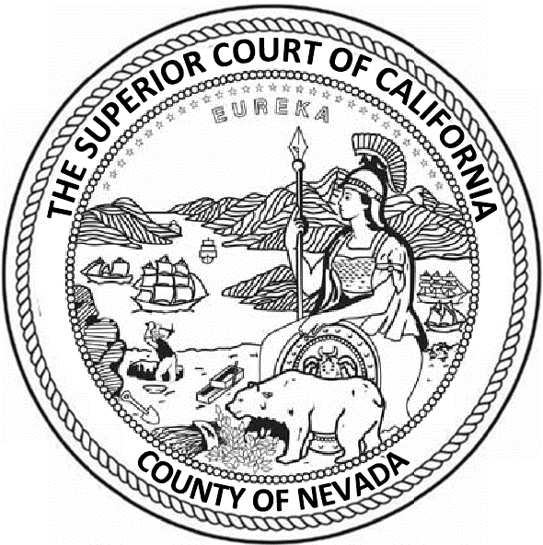
Superior Court of California
County of Nevada

RFP SP-2022-0002

Contract for Citation Processing Services

NOTICE OF INTENT TO AWARD
March 16, 2022

The Superior Court of California, County of Nevada, hereby gives notice of its intent to award a contract for citation processing services to: eData Services provided contract negotiations can be successfully finalized.

