- Portal filing (filing directly into a case via the Court’s case information lookup portal) is only allowed for certain case types and parties.
- Criminal Cases - Attorneys, Self-Represented Litigants, and Justice Partners
- Juvenile Cases – Appointed Attorneys, Unrepresented Parties, Justice Partners
Non-permitted cases/parties can file online via eFiling Service Providers (EFSPs). Document Filing | Superior Court of California | County of Nevada. Please note, EFSPs are outside agencies that the Court has no instructions to assist with.

- You will need to have token access granted on case to be able to file through the portal. If you provide an email at case initiation, you should be granted access automatically. If not, you can request access online at Party/Attorney Portal Document Access

- Once you have been granted access to a file, open the case on the Portal at Nevada Superior Court | Nevada Portal

- Look up your case on the “My Cases” tab. Any cases you already have access for should be listed there.
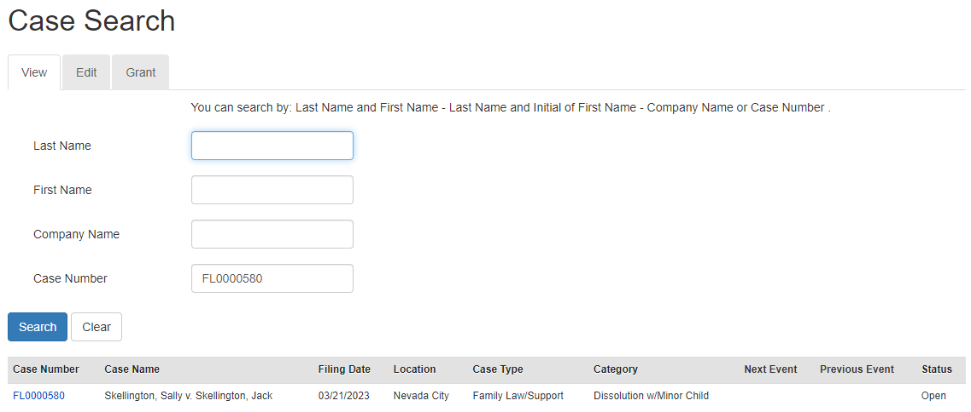
- Click on the Documents tab when the case opens. This will open a list of documents filed in the case.

- At the bottom there is a button to Add Document
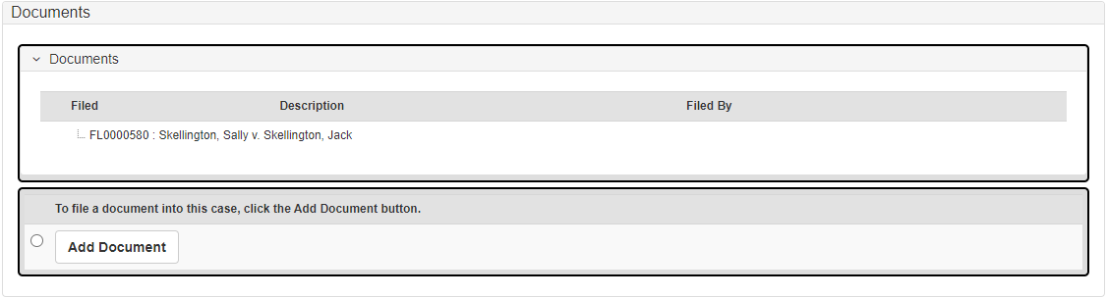
- When you click on the Add Document button, a new screen appears. In the bottom there is section to add a document titled “Add Document”.
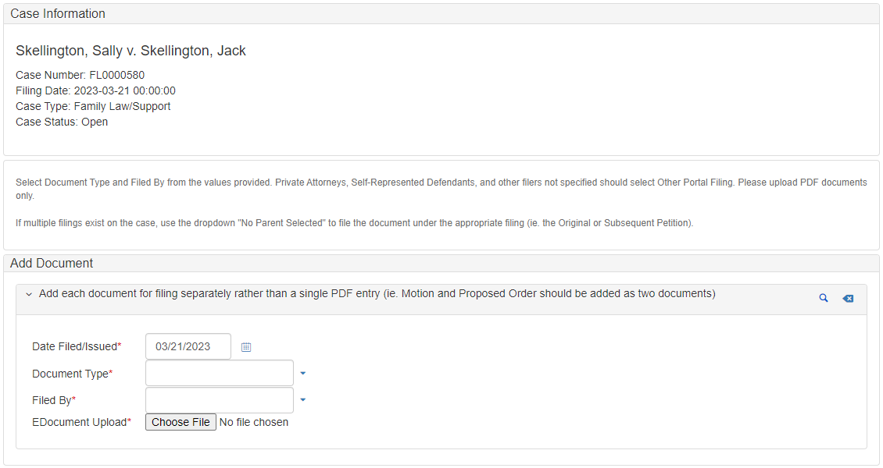
- Document Type asks you to identify which type of justice partner filing this is.
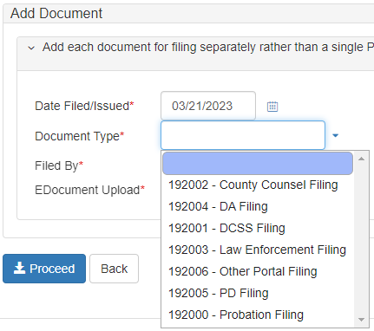
- Filed By asks you to specify who is actually filing the document.
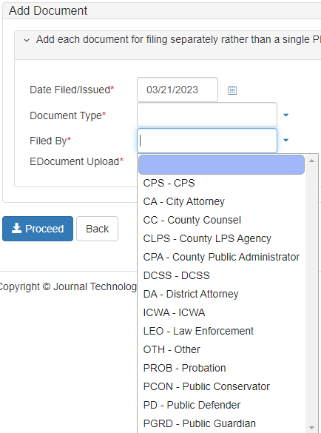

- Click the Choose File button to select a document to upload, then click Proceed to submit it to the Court. You will get a confirmation message if the form has been submitted successfully.

